OBTAINING DTDMA SLOT ALLOCATION PATTERN USING PIVOT TABLES IN EVENT TRACE FILE

- Enable Event trace and after simulation select Event Trace in the Simulation results window. Event tracing is available only in NetSim standard and Pro versions as of v10 or higher versions.
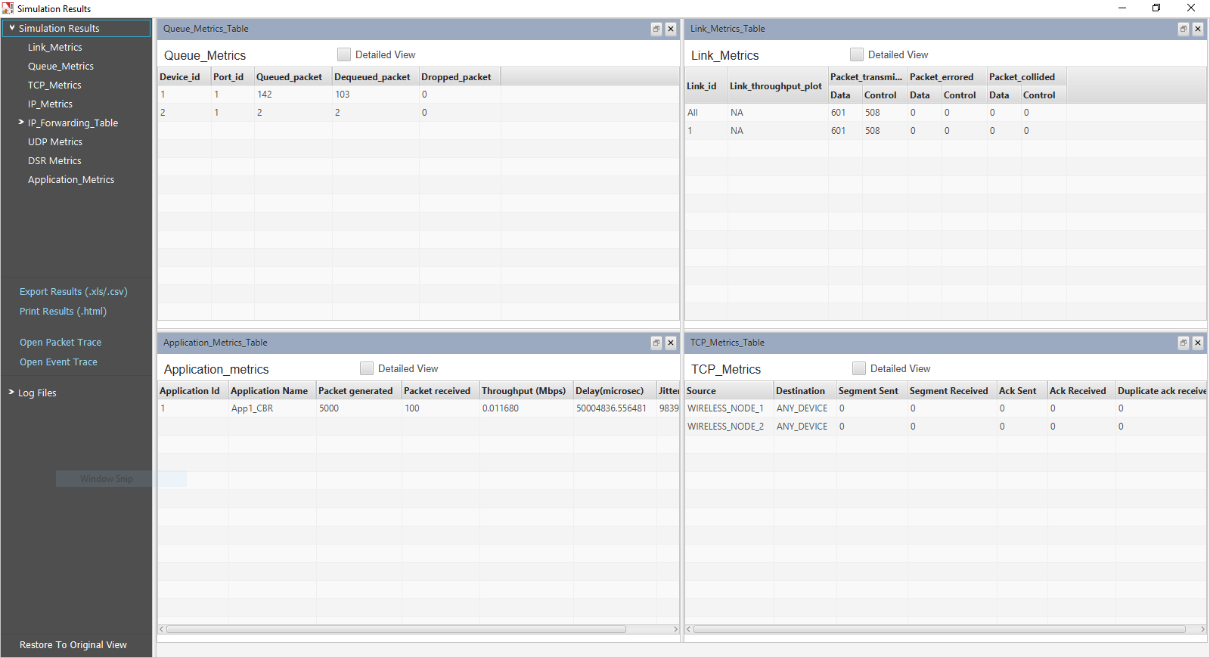
- Click on Pivot Table in INSERT tab

- Then a window named Create Pivot Table pops up which automatically selects the entire table, then click OK button. In case the entire table isn’t selected please enter the range such that all rows are selected.

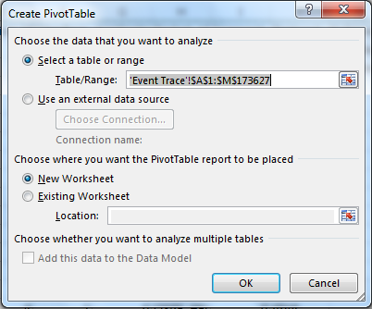

- A blank PivotTable and Field List will appear on a new worksheet.

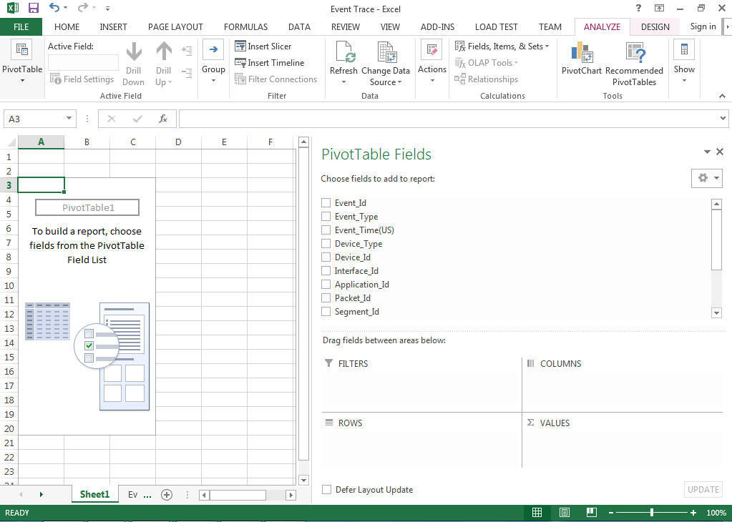

- Once you create a PivotTable, you'll need to decide which fields to add. Each field is simply a column header from the source data. In the PivotTable Field List, check the box for each field you want to add.

- Drag and drop field Event_Time to ROWS.
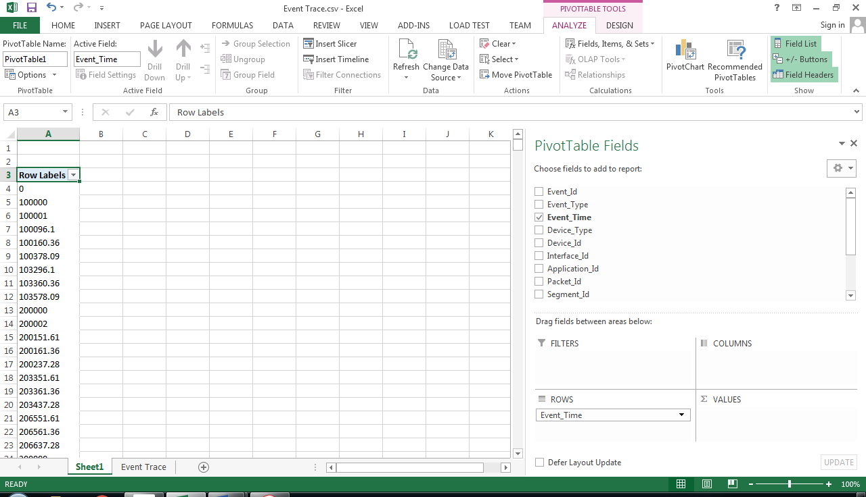

- Drag and drop fileld Subevent_Type to FILTERS.
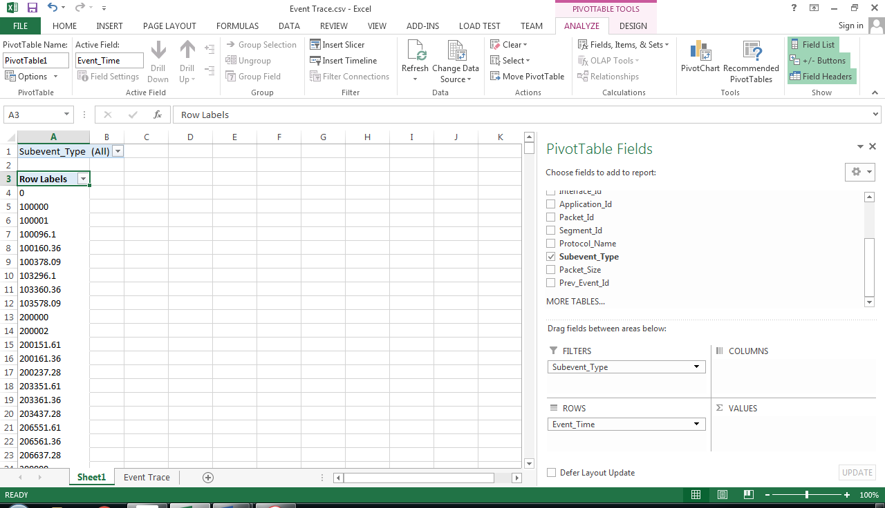

- In the Subevent_Type select DTDMA_SCHEDULE_TRANSMISSION and click on OK.

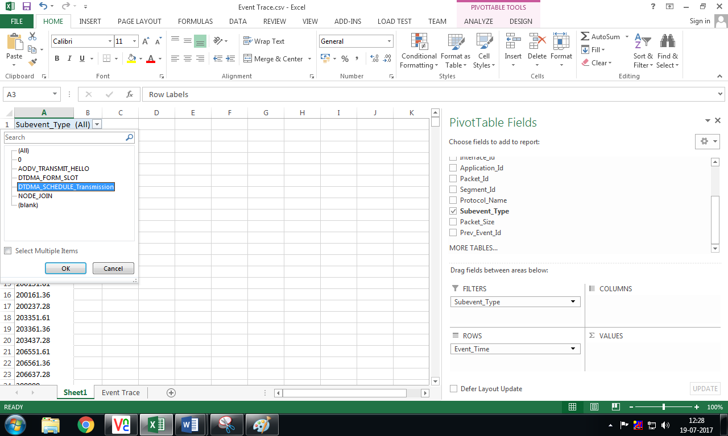

- Drag and drop Device_Id to VALUES.

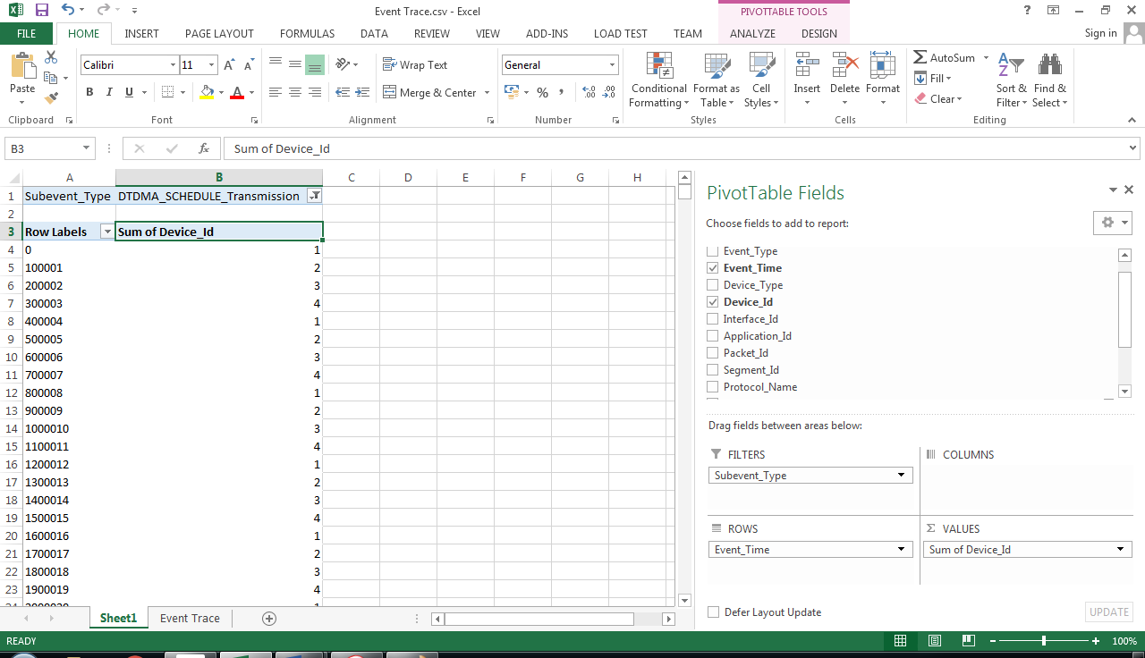

The pivot table created is shown below:
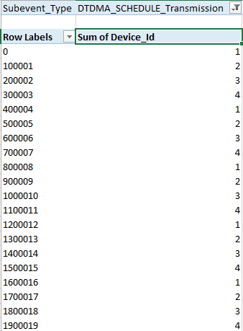

In the above table we have Slot start time and the corresponding Device Id to which the slot is allocated. Here we can see that the slots are allocated in a round robin manner, as we have used Round Robin Slot allocation technique in the MAC layer for this example.

