- Select Event Trace in the Simulation results window
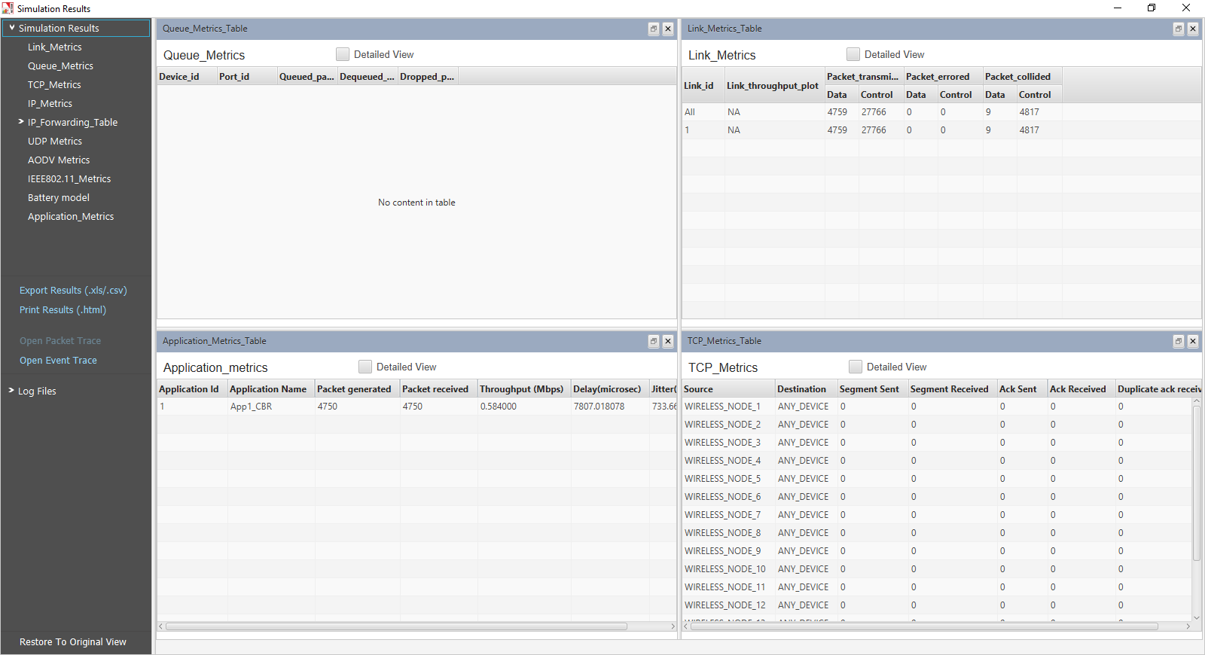
- Click on Pivot Table in INSERT tab

- The a window named Create Pivot Table pops up which automatically selects the entire table, then click OK button.

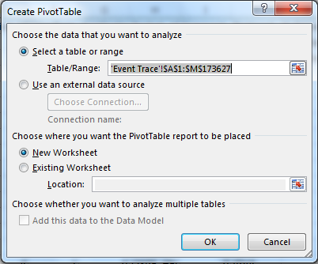

- A blank PivotTable and Field List will appear on a new worksheet.

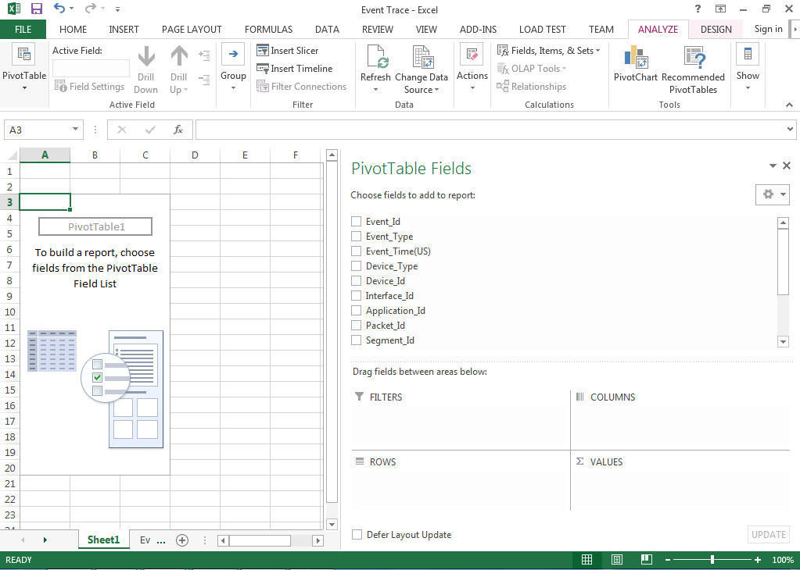

- Once you create a PivotTable, you'll need to decide which fields to add. Each field is simply a column header from the source data. In the PivotTable Field List, check the box for each field you want to add.
- Drag and drop the Event_Type, Application_Id Fields into FILTERS, Event_id and Packet_Id into ROWS and Device_Id into COLUMNS.
- Drag and Drop Event_Time Field into VALUES.
- Then finally the Pivot Table Fields will be as shown below.
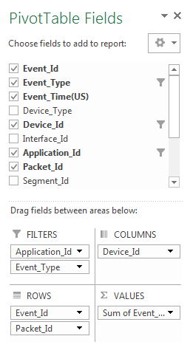
- In the Column Labels Select the Application_Id, in Event_Type select MAC_OUT and select Source_Id (15 in this case).

And the Pivot Table created will be as shown (15(in this case) is the Source_Id)
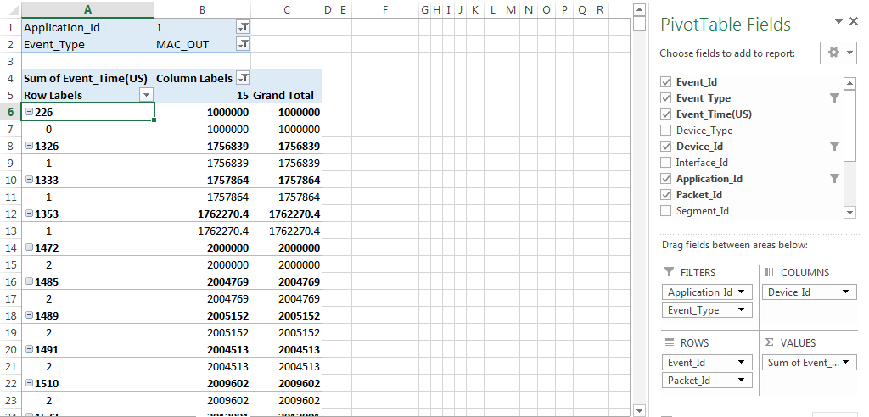

- Select one cell in Event_Id in Columns Labels and right click then deselect Subtotal “Event_Id”, it removes the Subtotals
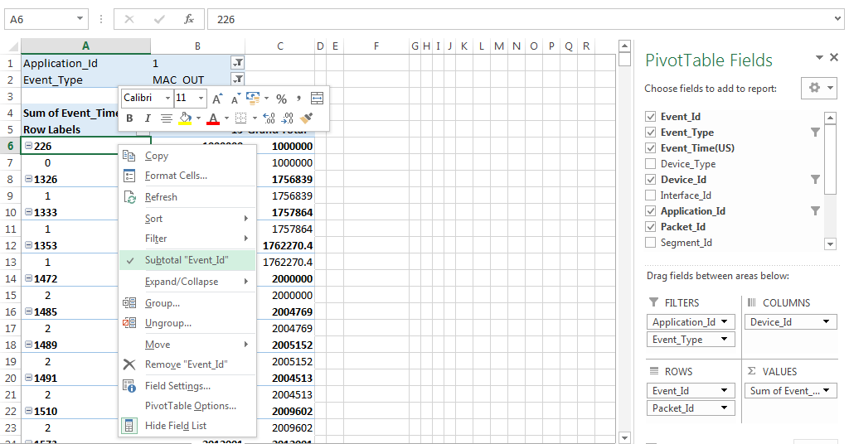
Then the pivot table will be as shown below
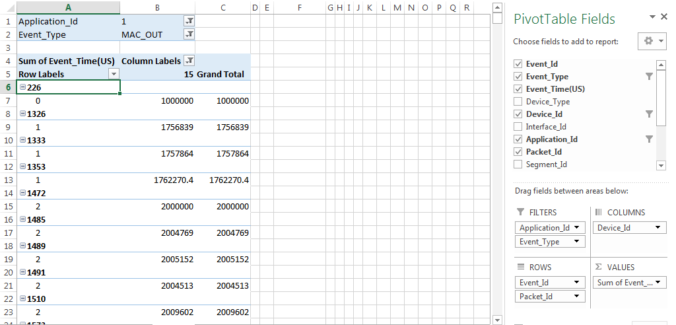

- Place the mouse just below Column Labels cell and left click then it will selects the rows of the pivot table as shown below
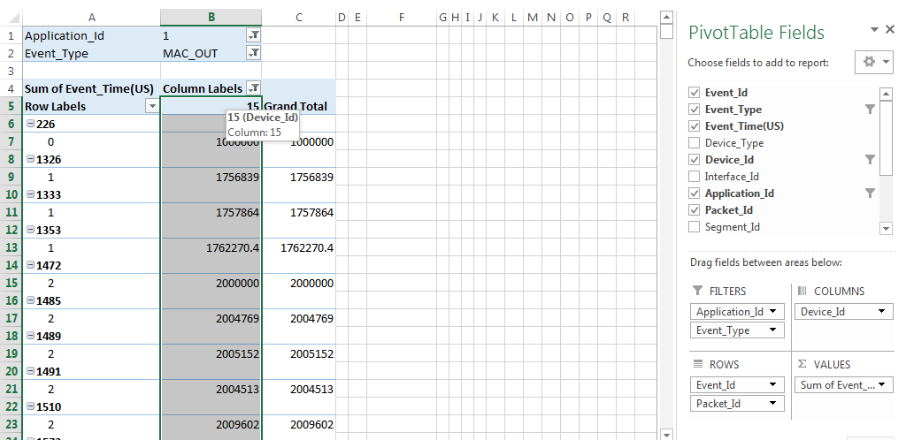
- Then in the Name Box name the column (APP_1 in this case), after that in an empty cell enter the formula to get the address of the empty rows Outside the pivot table
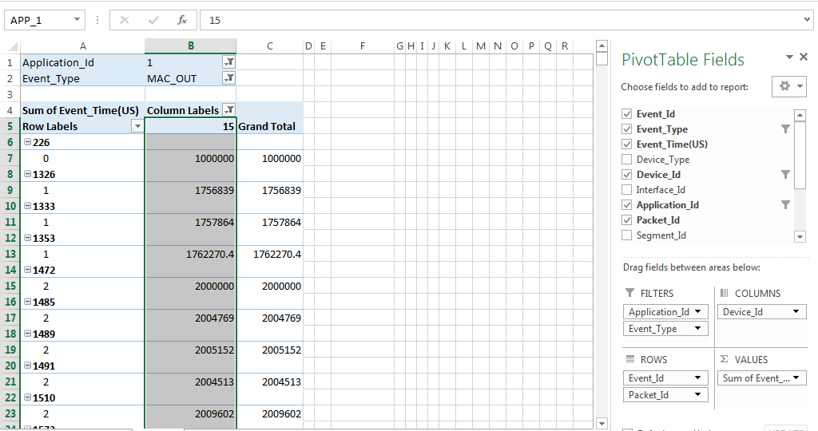
After that in an empty cell enter the formula =ADDRESS(ROW(APP_1)+1,COLUMN(D6))&":"&ADDRESS(ROW(APP_1)+ROWS(APP_1)-2,COLUMN(D6)) then press enter then you’ll get the address as shown below
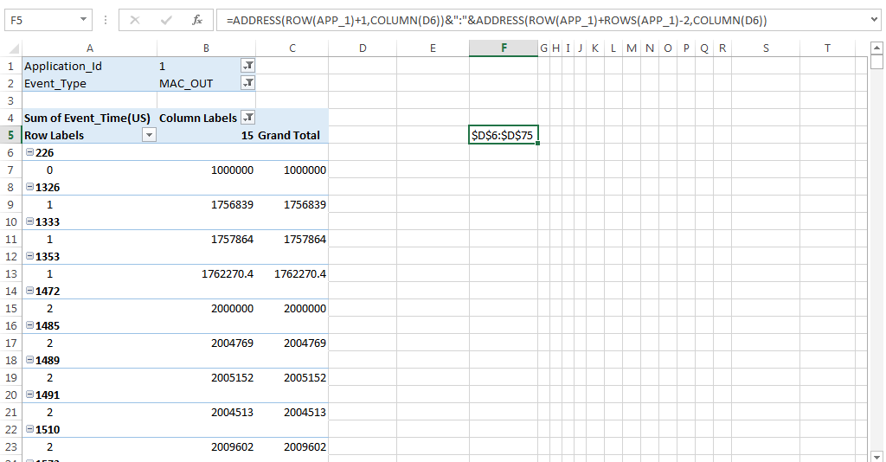
Then copy the address and place it in Name Box as shown below (Name Box is at the left top corner as shown below)
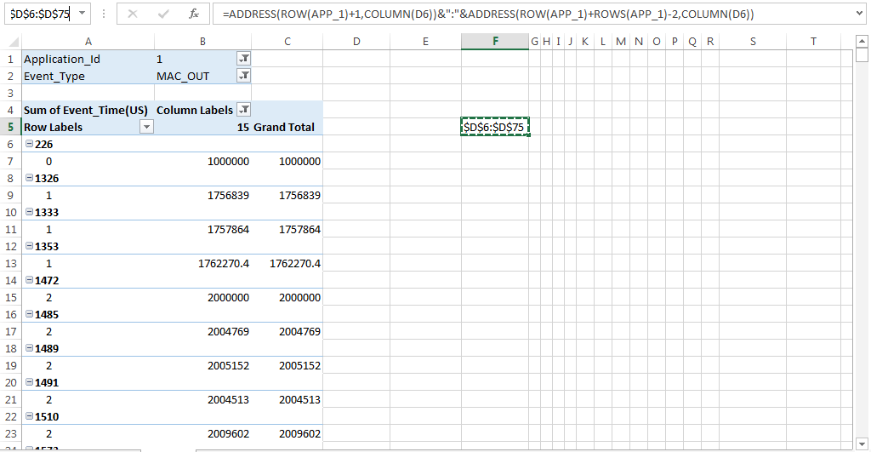
And press enter it will selects the Column D and Rows that are filled as shown
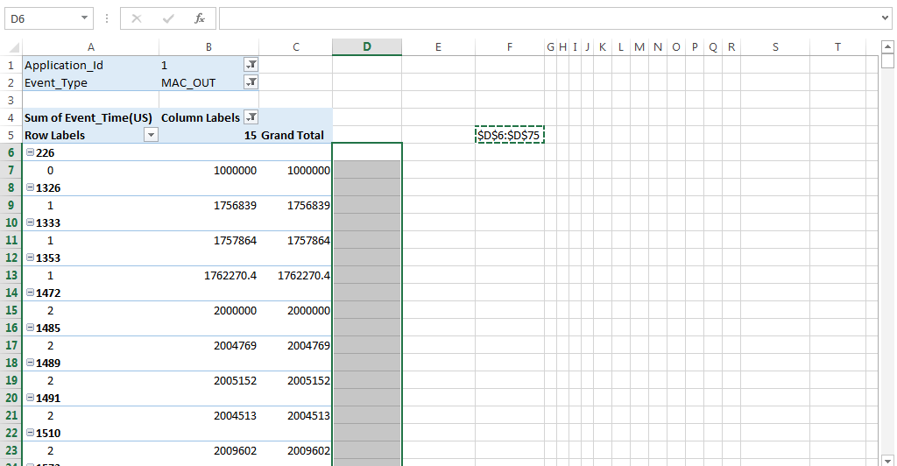
Then in the formula box type the formula =IF(B6<>0,IF(A4=0,B6-B4,""),"") and press CTRL + ENTER,
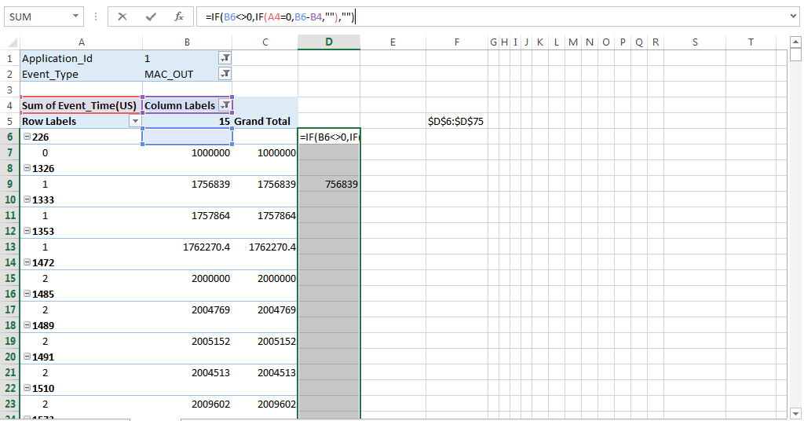
To get the Average Route Acquisition Time enter the formula =SUM(D6:D75)/COUNTIF(D6:D75,">0")
